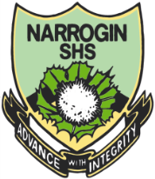
NAMA:__________________ KELAS: ______________

Bahasa Indonesia

Yr 7: Writing Assessment Term One

Total mark:  40 | % | Weight  20%
My estimated score out of 40: ____________

Time: 2 minutes reading + 30 minutes writing

Read each task below and respond accordingly using the Indonesian language. Try to vary the type of response to show a range of understanding of the Indonesian language.

1. Write a short dialogue (a conversation) between two people based upon the following: It is 4.00 in the afternoon; two people, Sandra and David, meet. They need to do the following:
- Greet each other according to the time of day
- Ask how each other are – “how are you?” (hint: give different replies for each person)
- Ask each other their names
- Thank each other and say goodbye

Sandra: ____________________________________________________________
David: _____________________________________________________________

_ _ _ _ : ____________________________________________________________
_ _ _ _ : ___________________________________________________________

_ _ _ _ : ____________________________________________________________
_ _ _ _ : ___________________________________________________________

_ _ _ _ : ____________________________________________________________
_ _ _ _ : ___________________________________________________________

_ _ _ _ : ____________________________________________________________
_ _ _ _ : ___________________________________________________________

_ _ _ _ : ____________________________________________________________
_ _ _ _ : ___________________________________________________________

_ _ _ _ : ____________________________________________________________
_ _ _ _ : ___________________________________________________________
(14 marks)

2. State the instructions in Indonesian that a teacher would use according to the images below.


(a) ______________________________________



(b) ______________________________________
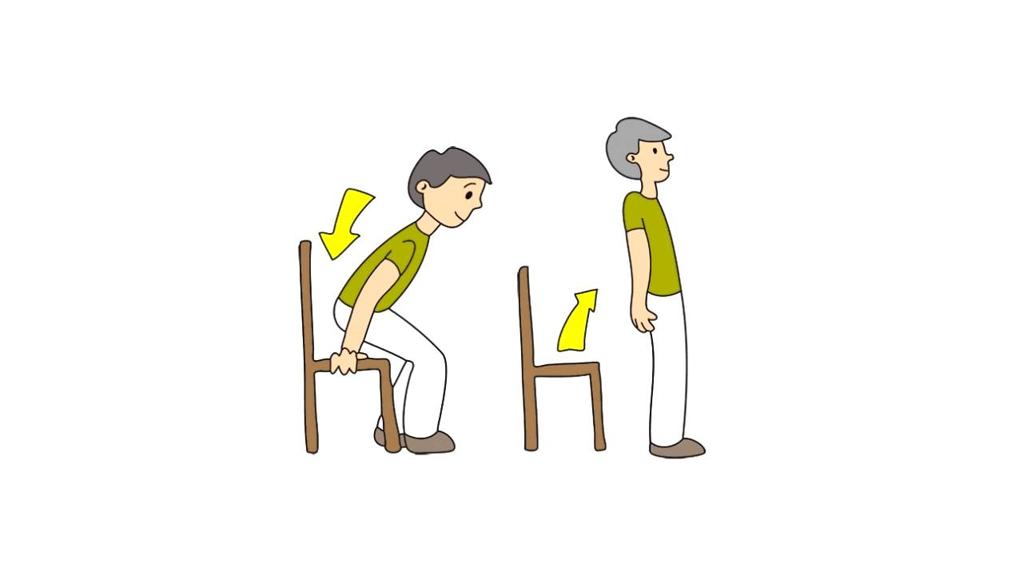

(c) ________________ (d) ________________



(e) ______________________________________

(5 marks)

3. Indicate below at least one more Indonesian language instructions or phrases that a teacher may use in the classroom.
____________________________________________________________________
(1 mark)

4. Use Indonesian colour and number words to label the following images, e.g. Dua dan biru (Two and blue):


(a) ______________________________________

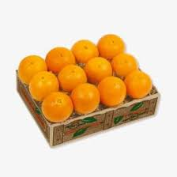
(Bananas)

(b) ______________________________________

(Oranges)



(c) ______________________________________

(Strawberries)
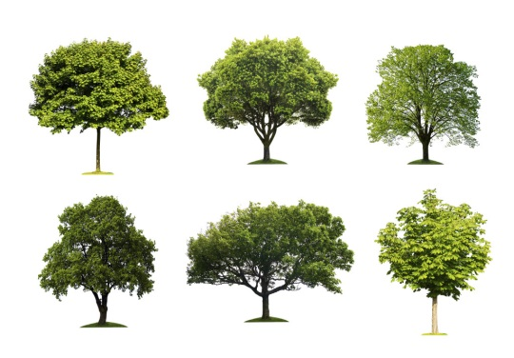

(d) ______________________________________

(Trees)



(e) ______________________________________

(Pink candles)

(10 marks)

4. Write four different sentences using the Indonesian language. Each sentence must include a different personal pronoun, as indicated:

(I/ me/ my)
(a) ______________________________________________________________________________________________________________________________

(You/your – to someone younger)
(b) ______________________________________________________________________________________________________________________________

(You/your – to someone older)
(c) ______________________________________________________________________________________________________________________________

(He/she)
(d) ______________________________________________________________________________________________________________________________

(They/ them/ their)
(e) ______________________________________________________________________________________________________________________________

(10 marks)

